姓名NAME-----------
一．写单词Write words.
1写出与bag中间字母发音相同的单词。
--------------------- ----------------------
2写出与pen中间字母发音相同的单词。
------------- 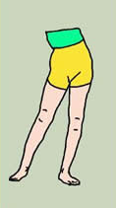----------------------
3写出与dog中间字母发音相同的单词。
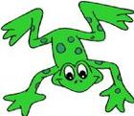--------------------- 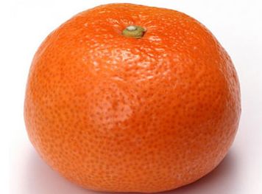----------------------
4写出与sit中间字母发音相同的单词。
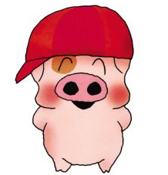------------------- ---------------------
5写出与cup中间字母发音相同的单词。
--------------------- 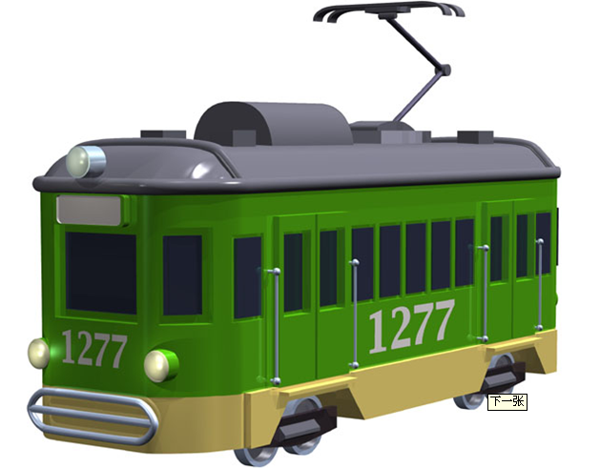------------------

二．选出正确的回答。Choose the best one.
1.Your name, please? ( )
A. Zhang Chenxi
B. This is my book.
C. Nice to meet you.
2.What’s this? ( )
A. It’s a goat.
B. It’s a long tail.
C. No.
3.What would you like,Sir? ( )
A. I’d like one, please.
B. I don’t like bananas.
C. I want some apples.
4.What’s on the table ? ( )
A. It’s blue.
B. An apple.
C. Smile, please.
5.What can you see? ( )
A. I can see a book..
B. I can hear a car.
C. I can write.
三．画怪物。Draw monster.
He’s got three eyes, two nose, one mouth, four ears, one neck, six arms, five legs.

